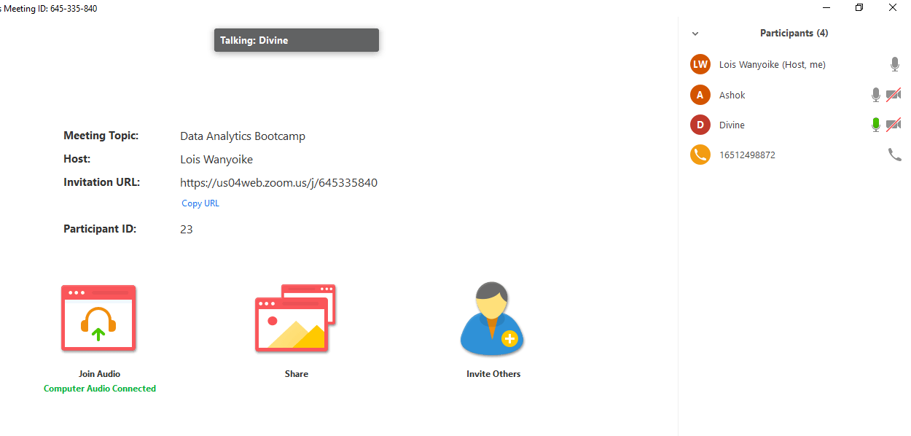

Divine – Working on Constraints

DJ – Working on Constraints

Ashok – Working on Constraints

Lois – Working on Constraints